Experiment 2.3

# Student Name: Rahul Kumar UID: 20BCS7081

**Branch: BE-CSE Section/Group:20BCS_DM-716 B**

# Semester: 6 Date of Performance: 10/04/23

**Subject Name: IOT LAB Subject Code: 20CSP_358**

# Aim:

To display Hello World on LCD using Arduino Uno.

# Objective:

* + Learn about IoT based simulations.
  + Learning the circuitry.

# Code-Output:

## Hardware Requirement o Arduino Uno

* + - LCD 16x2

## Jumper Wire

### About LCD:

A Liquid Crystal Display commonly abbreviated as LCD is basically a display unit built using Liquid Crystal technology. To display output values and messages.

JHD162A is a 16×2 LCD module based on the HD44780 driver from Hitachi. The JHD162A has 16 pins and can be operated in 4-bit mode or 8-bit mode. Here we are using the LCD module in 4-bit mode.

* **Circuit**

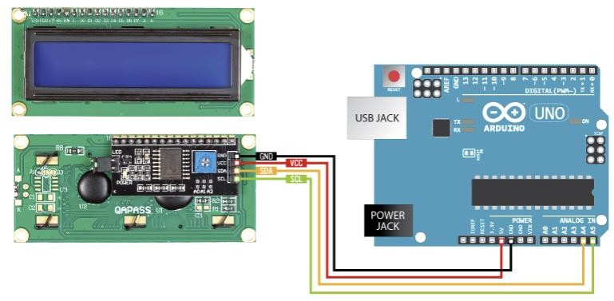

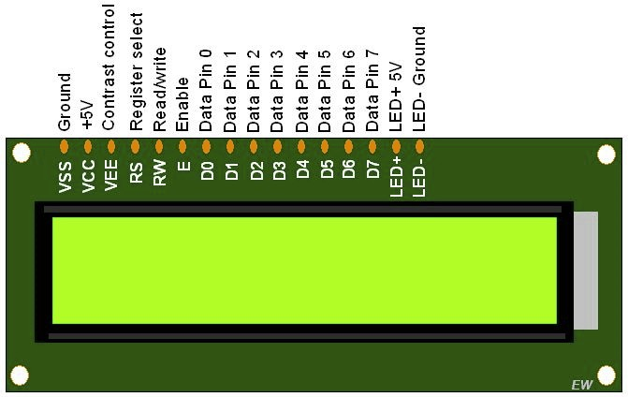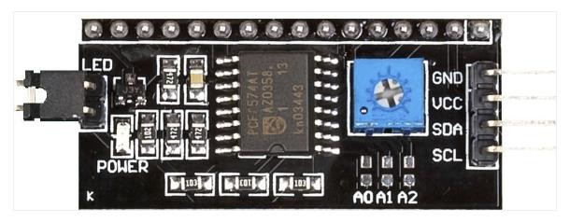

**Code :-**

#include <LiquidCrystal.h>

const int rs = 12, en = 11, d4 = 6, d5 = 5, d6 = 4, d7 = 3; LiquidCrystal lcd(rs, en, d4, d5, d6, d7);

void setup() {

lcd.begin(16, 2); // set up the LCD's number of columns and rows: lcd.print("Hello World!"); // Print a text to the LCD.

}

void loop() { // set the cursor to column 0, line 1

SDA – Serial Data

SCL – Serial Clock

lcd.setCursor(0, 1); // (note: line 1 is the second row, since counting begins with 0): lcd.print(millis() / 1000); // print the number of seconds since reset:

}

### OUTPUT :-

